___

Literacy  Phonics and reading  Fine motor/ Handwriting  Whole class Texts | Individual phonics/spelling; recapping previous sounds, introducing new sounds, sounding out and blending to read words, initial sounds, rhyming skills onset and rime, reading HFW and tricky words. CVC CCVC CVCC words. Bucket time, colouring, sand writing, “Squiggle while you wiggle”  The Magic bed- Words spelled with single vowel graphemes, some representing short vowel sounds and some representing long ones. Common exception words - you, your, put, push, are, to, of.  Billy and the Beast - a-e, e-e, i-e, o-e,u-e; air, ear(/ɛə/), ear are(/ɛə/). Common exception words - you, they, are, she, her, there, where.
Cutting, knife and fork skills, shoe laces, zips, buttons, threading, hama beads, filling bottles using funnels, finding objects in thera-putty, peg boards, posting, play dough disco
Handwriting – overwriting shapes/letters/numbers, writing letters, words, high frequency words, tricky words, numbers, drawing,

 | The Magic bed | Billy and the Breast
 | 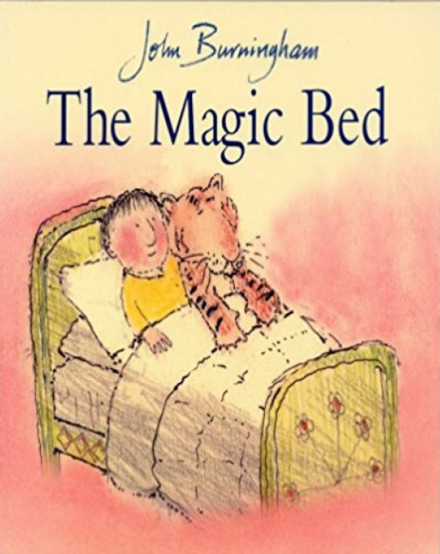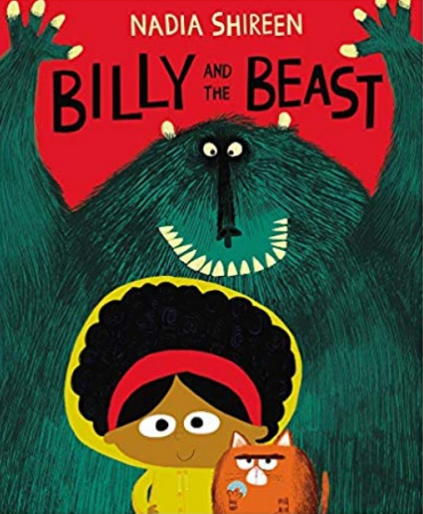

EYFS | Length, height and time | Building 9 and 10 |  |  | Explore 3D shapes
KS1 | Place value (within 50) |  | Length and height | Mass and Volume |  | Statistics

Sensory Play | Wet  Water tray investigation. To investigate, whether objects sink or float. | Dry  Funky fingers. Using tools overcome barriers and solve the problem. Masking tape, feathers, and tweezers. | Wet  Hand washing. Can you wash the germs of the hands? | Wet  Mini beast hunt.  Soil, bugs, magnifying glass, mini beast hunt checklist. | Dry  ‘Billy and the beast’ terrible soup | Wet  Compare the weight of the objects.
Sensory Play | Wet  Rainbow ice painting.  Ice blocks, paint. | Dry  Sand and seashells. | Wet  Bubble wrap roller painting.  White paper, roller, bubble wrap, paint. | Wet  Fruit and vegetable printing | Dry  Making a silky playdough.  8 parts of flour, 1 part of baby oil. | Wet  Counting carrots activity. Rice, empty egg boxes, carrot sticks.

Art | Dream catcher | Clay vase | Celebration card | Cat painting | Sun catcher | Easter chicken

Social context / PSHE | Individual to class/pupil needs – Group sessions, 1:1 tutorial, Thrive;  E.g. class and playtime promises, sharing toys and resources, turn-taking, kind hands, Makaton register, Sign of the Week;  Reward systems: reward time, Marvellous Me;

Home learning | E-Collins books assigned on Fridays;  Shared books changed Tuesday and Friday;  Spellings where appropriate on Spelling Shed;  Maths Shed – assigned year group appropriate;

Life Skills

