___

Literacy  Phonics and reading  Fine motor/ Handwriting  Whole class Texts | Individual phonics/spelling using Little Wandle; recapping previous sounds, introducing new sounds, sounding out and blending to read words, initial sounds, rhyming skills onset and rime, reading HFW and tricky words. CVC CCVC CVCC words. Bucket time, colouring, sand writing, “Squiggle while you wiggle”.  The Magic bed- Words spelled with single vowel graphemes, some representing short vowel sounds and some representing long ones. Common exception words - you, your, put, push, are, to, of.  Varmints –
Cutting, knife and fork skills, shoe laces, zips, buttons, threading, hama beads, filling bottles using funnels, finding objects in thera-putty, peg boards, posting, play dough disco
Handwriting – Letter Join overwriting shapes/letters/numbers, writing letters, words, high frequency words, tricky words, numbers, drawing

 | The Magic Bed | Varmints
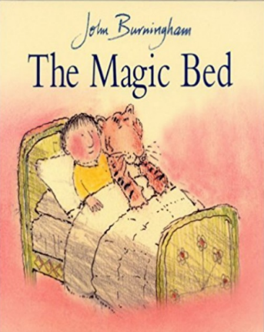
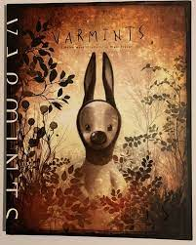

KS1 | Place value (within 50); Length & Height | Addition and subtraction (within 20)
KS2 | Length & Height; Times Tables (2,5 &10) | Addition and Subtraction (making the exchange)

Sensory Play | Wet  Water tray investigation. To investigate, whether objects sink or float. | Dry  Funky fingers. Using tools overcome barriers and solve the problem. Masking tape, feathers, and tweezers. | Wet  Hand washing. Can you wash the germs of the hands? | Wet  Mini beast hunt.  Soil, bugs, magnifying glass, mini beast hunt checklist. | Dry  ‘Billy and the beast’ terrible soup | Wet  Compare the weight of the objects.
Sensory Play | Wet  Rainbow ice painting.  Ice blocks, paint. | Dry  Sand and seashells. | Wet  Bubble wrap roller painting.  White paper, roller, bubble wrap, paint. | Wet  Fruit and vegetable printing | Dry  Making a silky playdough.  8 parts of flour, 1 part of baby oil. | Wet  Counting carrots activity. Rice, empty egg boxes, carrot sticks.

Art | Dream catcher | Patterns | Metre Monsters | Dream Jars | Clay Building Flower Pots | Easter Crafts

Social context / PSHE | Individual to class/pupil needs – Group sessions, 1:1 tutorials, Thrive;  E.g. class and playtime promises, sharing toys and resources, turn-taking, kind hands, Makaton register, Sign of the Week;  Reward systems: sunflower reward chart, reward time, Marvellous Me;

Home learning | E-Collins books assigned on Fridays;  Shared books changed Tuesday and Friday;  Spellings where appropriate on Spelling Shed;  Maths Shed – assigned year group appropriate;

Life Skills | Navigation | Staying Safe Outside | Road Safety Walk | Road Safety | People Who Help Us | Shopping

