___

Literacy  Phonics and reading  Fine motor/ Handwriting  Whole class Texts | Individual phonics/spelling using Little Wandle; recapping previous sounds, introducing new sounds, sounding out and blending to read words, initial sounds, rhyming skills onset and rime, reading HFW and tricky words. CVC CCVC CVCC words. Bucket time, colouring, sand writing, “Squiggle while you wiggle”.  The Odd Egg - Sounds to be introduced: consonant diagraph –ng; Adding the endings -ing, -ed and -er where no change is needed to the root words. Common exception words - put, push, pull, full.  Tadpole’s Promise - The /aɪ/ sound spelt –y at the end of words; The suffixes –ment, –ness, –ful, –less and –ly. Common exception words beautiful, both, break, mind, old, only, prove, sure, told, wild.
Cutting, knife and fork skills, shoe laces, zips, buttons, threading, hama beads, filling bottles using funnels, finding objects in thera-putty, peg boards, posting, play dough disco
Handwriting – Letter Join overwriting shapes/letters/numbers, writing letters, words, high frequency words, tricky words, numbers, drawing

 | The Odd Egg | Tadpole’s Promise
 | 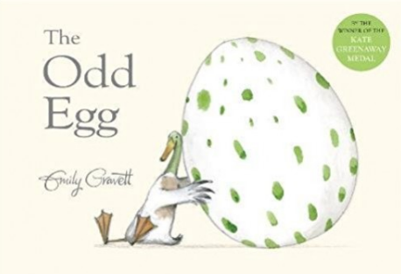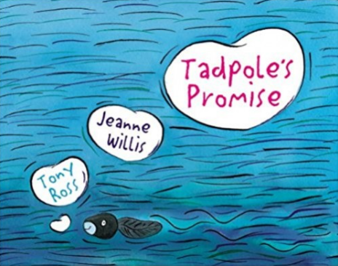

KS1 | Place value (within 20) | Addition and subtraction (within 20)
KS2 | Place Value | Addition and Subtraction

Sensory Play | Wet  Foamy eggs.  Add cubes with sounds to the shaving foam. Children fill the eggs with foam and the chosen sound. | Dry  Odd egg rescue. Motor skills. Put eggs on the tray, and use masking tape to tape the tray around. Use a cooking spoon to rescue the eggs. | Wet  Egg number matching puzzle. Practice counting and number recognition. | Wet  Investigation. Soil, plastic bugs and magnifying glass. | Dry  Coloured rice measuring station. Full cup, half of cup, nearly full, nearly empty. | Wet  Muddy worm sensory bin. Oats, boiled spaghetti (dyed) and kitchen tongs.
Sensory Play | Wet  Sink the egg.  Can you guess what will sink the egg? Fill eggs with different materials/objects. | Dry  Egg hunt.  Shredded paper, kitchen tongs, counters and plastic eggs. | Wet  Find all hiding numbers in the egg box snow world? (Egg boxes, cotton, rice, numbers, South Pole animals). | Wet  Life cycle of the frog.  Sensory bin – water, glue, starch, chia/basil seeds, plastic frogs, foam sheets. | Dry  Pour rice in the tray, add cubes with sounds. | Wet  Colourful jelly station.  Jelly, plastic bugs and worms.

Art | Artistic Book Cover Designs | Odd Egg Collage | Bird Nests and Paper Plate Ducks | Frog Lifecycle Art | Abstract Butterfly/Frog Art | Flower prints

Social context / PSHE | Individual to class/pupil needs – Group sessions, 1:1 tutorials, Thrive;  E.g. class and playtime promises, sharing toys and resources, turn-taking, kind hands, Makaton register, Sign of the Week;  Reward systems: sunflower reward chart, reward time, Marvellous Me;

Home learning | E-Collins books assigned on Fridays;  Shared books changed Tuesday and Friday;  Spellings where appropriate on Spelling Shed;  Maths Shed – assigned year group appropriate;

Life Skills | Thinking Positively & Acceptable Behaviour | Healthy Living | Healthy Eating | Food Preparation and Cooking | Personal Hygiene and Caring For Our Bodies | Staying Safe At Home

