___

Literacy  Phonics and reading  Fine motor/ Handwriting  Whole class Texts | Little Wandle SEND Programme: Individual phonics phase/spelling; recapping previous sounds, introducing new sounds, sounding out and blending to read words, initial sounds, rhyming skills, reading HFW and tricky words. CVC CCVC CVCC words. Bucket time, colouring, sand writing, “Squiggle while you wiggle”.
Cutting, knife and fork skills, shoe laces, zips, buttons, threading, hama beads, filling bottles using funnels, finding objects in thera-putty, peg boards, posting, play dough disco
Handwriting – Letter Join - overwriting shapes/letters/numbers, creating letters, writing letters, words, high frequency words, tricky words, numbers, drawing
 | The Wilderness by Steve McCarthy | The Heart and the Bottle by Oliver Jeffers
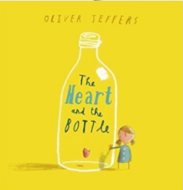
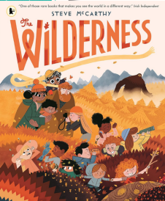

Lower KS2 | Place value (within 10) |  | Addition and subtraction (within 20)
Upper KS2 | Place value (up to 100) | Addition and subtraction (up to 100)

Sensory Diet  Art | Dry  Twig family craft based of class text characters | Dry  Twig and string art ornaments - Tepees | Wet  Nature boats – how will they float? | Dry  Nature name tags | Dry  Clay nature imprints ornaments | Dry  Create ‘The Great Outdoors’ using natural objects
Sensory Diet  Art | Dry  Big feelings | Dry  My heart in a bottle - Feelings jars | Dry  Self – love heart wreaths | Wet  Multi-media love hearts | Dry  Memory stones – painting our memories | Dry  Threading – memory bracelets
Social context / PSHE | Individual to class/pupil needs – Group sessions, 1:1 tutorials, whole class ELSA;  E.g. class and playtime promises, sharing toys and resources, turn-taking, kind hands, Makaton register, Sign of the Week;  Reward systems: Bumblebee reward chart, reward (Golden) time, Marvellous Me, house points, WOW work.

Home learning | E-Collins books assigned on Fridays;  Shared books changed Tuesday and Friday;  Spellings where appropriate on Spelling Shed;  Maths Shed – assigned year group appropriate;

